Barrow SMPS Monthly Checks (2016)
- Enter a message in the aerosol computer log that you are doing the monthly SMPS checks .
- Press the “Service Mode” button on the front screen of the Scan.vi program
1.) Zero-Check (checks for leaks/problems with CPC):
- Turn the zero/flowcheck valve above the sheath column upwards (fig 1). Attach a zero filter to the other end of the air line connected to the top of the column.
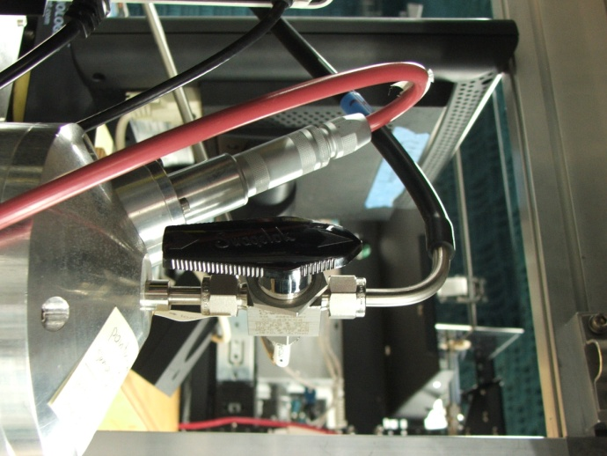 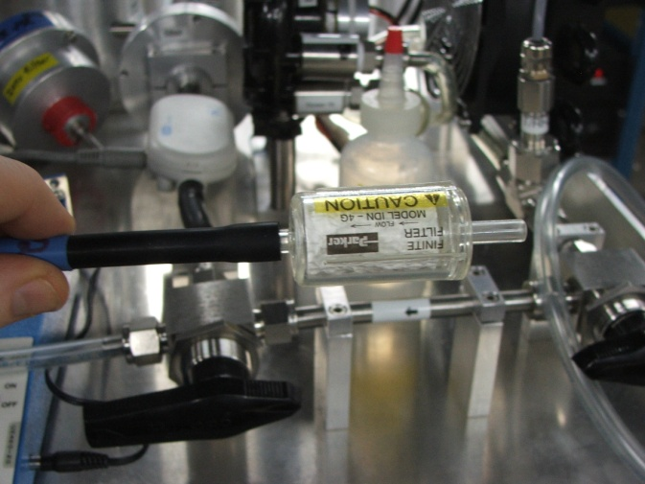 Figure 1 – zero/flowcheck valve (zero position) Figure 2 – zero filter
- Wait 5 min. to flush out particles.
- Make sure the CPC concentration counts are displayed in PT/CM^3. Toggle by pushing [display] on the CPC.
- Observe concentrations. Counts should be less than 1.0 PT/CM^3

2.) Aerosol Flow Check
- Rotate the zero/flowcheck valve (fig 1) back so that it points down toward the top of the column.
- Connect the air line to the gilibrator outlet instead of the zero air filter. (fig 3)
- Add a small amount of a weak soap solution (not pure soap!) to the lower nipple of the gilibrator using the fill bottle.
- Check flows using the gilibrator. Push the black button on the bottom of the gilibrator to produce bubbles rising in the column. Record the average of 4-5 readings.
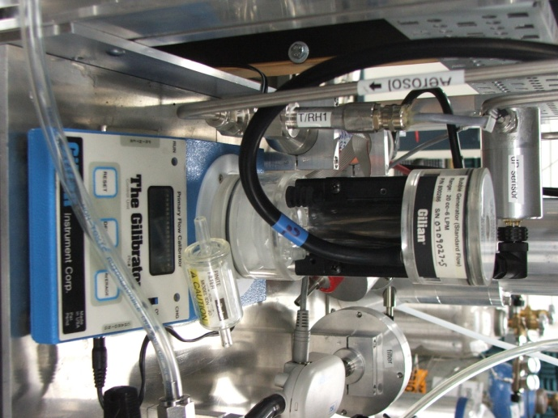
Figure 3 – Gilibrator during aerosol flow check,

Gilibrator Notes:
- The gilibrator measures in cc/m. (1000cc/m = 1 LPM)
- Start by adding enough soap to cover base of gilibrator, add as needed to produce bubbles rising in the column
- Bubbles will not rise in column unless there is correct flow.
- To get a correct reading you will need to need to have a single clean level bubbles rise through the column.
- You will need to reset the averages on the gilibrator several times to ensure that only good readings are averaged and reported to you.
- After use the gilibrator needs to be cleaned. (at the least flushed with water enough to avoid soap build up)

- Record the original and final aerosol flows to the SMPS system log (SMPS notes.txt).

3.) Sheath Air Flow Check
- Switch the sheath air valves to the sheath air flow check position (fig 5).
- Connect the clear tubing attached to the sheath air valves to the inlet and outlet of the gilibrator as shown (fig5). Right tube on lower port and left tube on upper port of gilabrator.
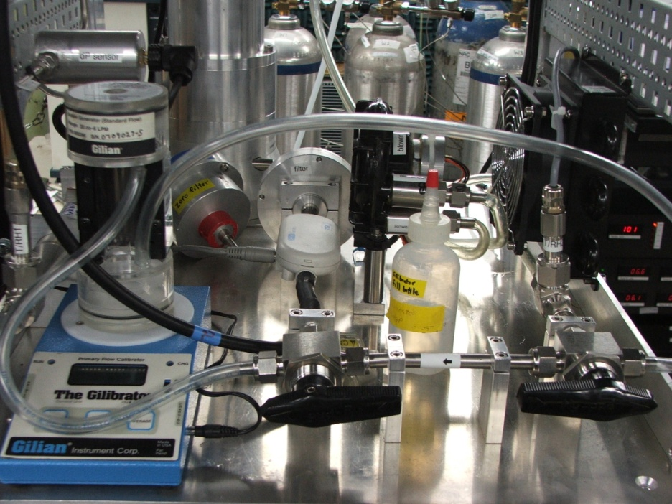
Figure 5 - sheath air valves in sheath air flowcheck position
- Wait for stabilization of sheath air flow mean value (number labeled ‘mean’ in scan.vi)
- Measure flow using the gilibrator, attached as in picture above. (consecutive bubbles are OK but you don’t want mal-formed bubbles, reset averages as needed to get correct readings)
- If the flow is outside of the 5.0 +/- 0.1 LPM range the sheath flow needs to be adjusted.
Sheath air flow meter adjustment
- Open the Measurement and Automation program (shortcut on the desktop).

Figure 6 - Measurement and Automation Program
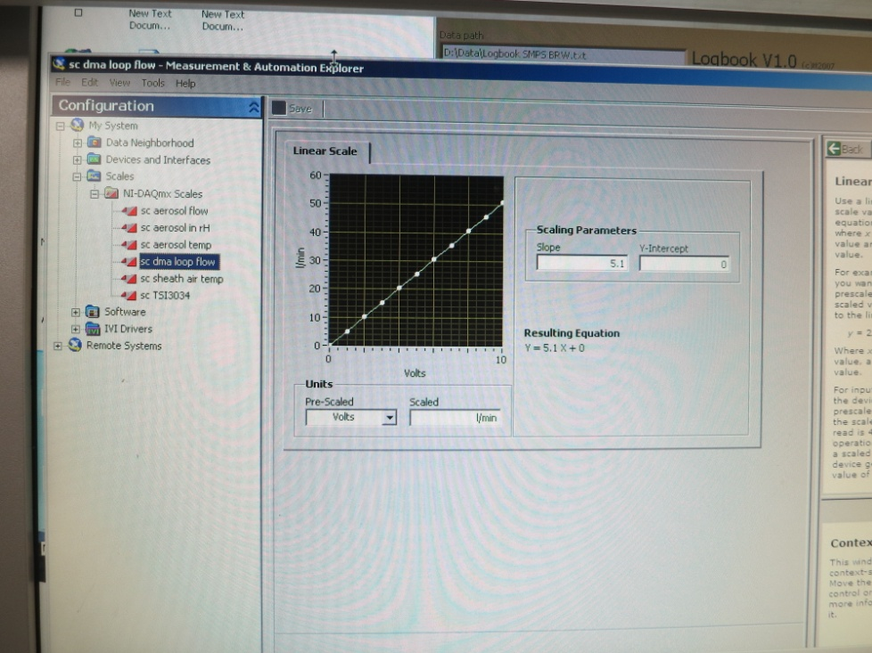
- Navigate through the configuration menu.
- Scales
  - NI-DAQmx scales
- sc dma loop flow
- Click on ‘sc dma loop flow’
- Modify the slope value slightly .
- Press SAVE button, this will adjust the flow meter reading.
- Go back to the seflow.vi program wait until the setflow.vi has completed its calibration cycle and adjusted the blower voltage.
- Again, measure the flow rate in the gilibrator and repeat the adjustment process for changing the slope in the Measurement and Automation program until the sheath flow is within the range of 5.0 LPM +/- .1 LPM as measured by the gilibrator.
- Once a correct sheath flow is established, you can close the Measurement and Automation program, and prepare the system to return to running scans.

Finishing Up
- Return the zero/flowcheck valve to downward sampling position (fig 8).
- Switch sheath air valves back to regular operating position, pointing inwards (fig 7).
- The CPC should remain in concentration display.
- Restart scan.vi program with shortcut on desktop. Scans should automatically commence.
- Record the flow values in the SMPS notes.txt file.

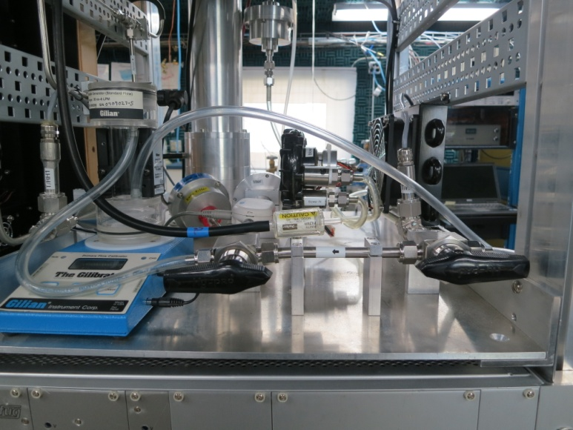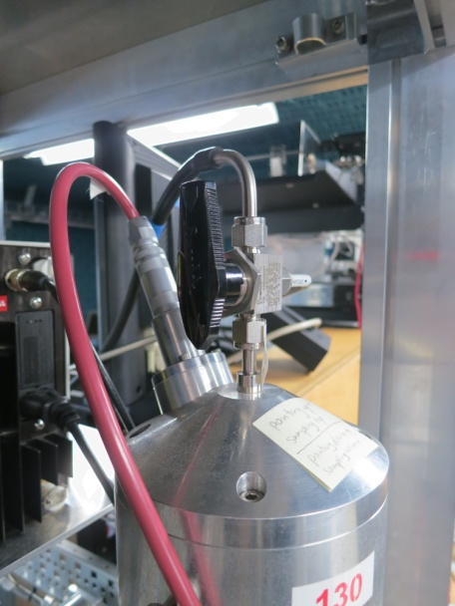
figure 7 – sheath flow valves, regular operation figure 8 – zero flowcheck, downward position

